A

Project on

Bibliography Manager

CS615  
Internet Solutions Engineering

(National University of Ireland, Maynooth)

Submitted By

Sankalp S. Motke()

Chun-Hung Chen()

Yashaswini Boddupalli(18251976)

Guided By

Dr. Ralf Bierig

**Introduction**

Bibliography Manager is a tool specially designed for the researcher for collecting and organizing literature. The application is capable of storing a metadata about the research paper, books, journals and other publications. Researcher can create their own libraries which will contain metadata about different references. Also, researchers can share their own libraries with other researcher with specific permissions.

**Technologies and Tools used**

The technology used in the project are as follows: -

|  |  |
| --- | --- |
| * HTML * CSS * Bootstrap 4 * W3-CSS | * jQuery * JavaScript * PHP |

Tool used in the project for dealing with database

|  |
| --- |
| phpMyAdmin |

Web-Server Details

|  |
| --- |
| XAMPP open-source cross-platform web server solution stack package developed by Apache |

**Why these Technologies?**

* **Bootstrap 4:** Bootstrap 4 is a flexible and powerful front-end framework that provides a free collection of tools for our web application. As we have also used HTML, CSS and JavaScript technologies, Bootstrap4 helped us in faster front end web development and making it responsive for mobile users as well. Major role of selecting Bootstrap is that it helped us to maintain consistency and cross browser compatibility.

The main reason for using Bootstrap 4 instead of Bootstrap 3 is to use ‘JS tab’ feature for our dashboard main navigation. We also used Bootstrap for the header part of our website.

*Bootstrap4 JS tab*

*Bootstrap 4 for header*

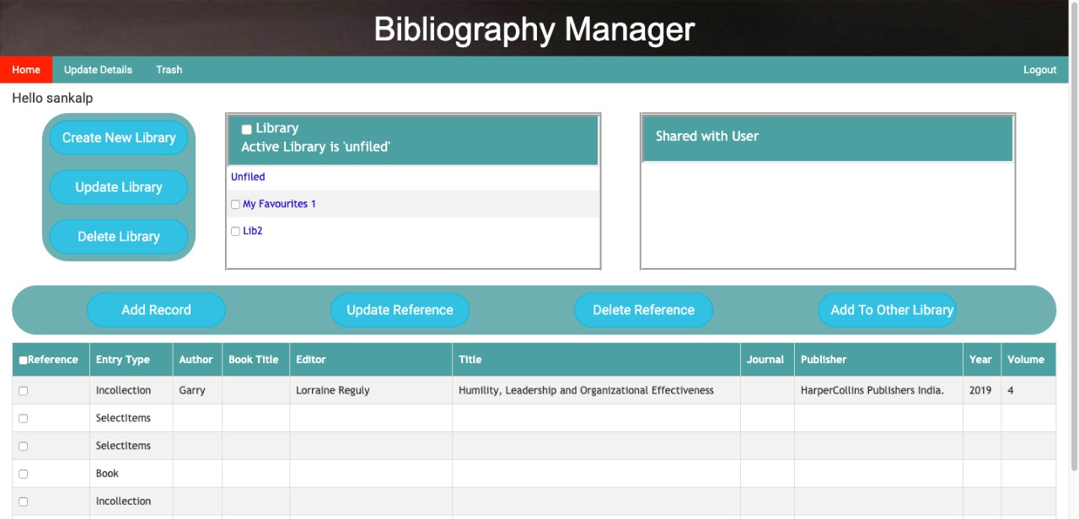

*Figure 1: Dashboard of Bibliography Manager and technologies used.*

* **W3-CSS:** supports responsive mobile first design by default and this language is one of the frameworks of CSS. In order to make our website mobile friendly, we used W3-CSS especially for from designs like Sign-in, Sign-Up etc.
* **jQuery:** is used for popovers, accordions, sliders, modals, search data in the table etc. that we have used in our project and the other main reason for using jQuery, is used to load the related files in the tabs. For example, when the ‘Home’ is clicked in the main navigation as shown in the figure 1.
* **JavaScript:** We have used JavaScript in order to do validation on client side such as restricting the user from entering wrong input, checking the password strength and to provide feedback to the user.
* **PHP –** As we have chosen our database to be MySQL. So, we choose PHP language easy to interact with the database along with that it is very easy to setup and design website. Apart from this we always wanted to learn PHP so it was a golden chance for us to learn a new language.

We also used PHP for server-side validation. For example, when the user registers, we check whether the entered password matches the confirm password, whether the entered email address already exists, etc.

**Security measures:**

* **Client side:**  We used client input validations in order to avoid SQL injections. During registration phase, the email address format, the password strength and password length minimum of eight characters long is checked.
* **Server side:** We made sure the client data is secured on the server side. Especially the sensitive data like password. So, we applied the Sha1 to the password to keep them secured on the server side.

**Testing (Usability Testing):**

Due to time-constraints we conducted usability testing with only one user. However, we got so much useful feedback from the user the following are some of the key areas we improved in our website after getting feedback from the user:

1. We changed the “Update details” page in which users can update their profile easily.
2. We combined “Home” page and “Library” pages into the main “Home” page in which the users perform all required tasks at one page like create library, share library etc.
3. We also added security measures for password and real time feedback when the user registers with the website (Signup page).

The full video recording for the usability testing can be accessed from the following link below:

<https://maynoothuniversity-my.sharepoint.com/personal/chunhung_chen_2019_mumail_ie/_layouts/15/guestaccess.aspx?e=4%3anfBtru&at=9&share=EQHddiRY05JGiwESzAGkUU0BpMk9GJWHs0gFCn0Ry8BvIQ&cid=44be1f63-3b29-4951-94ad-0011a58ecf1e>

The test script for the usability testing is taken from the following textbook:

“Rocket surgery made easy the do it yourself guide” by Steve Kurg. [ test-script from page 152 to 157].

The recording contest from for the usability testing is also taken from the following textbook:

“Rocket surgery made easy the do it yourself guide” by Steve Kurg. [ test-script from page 158].

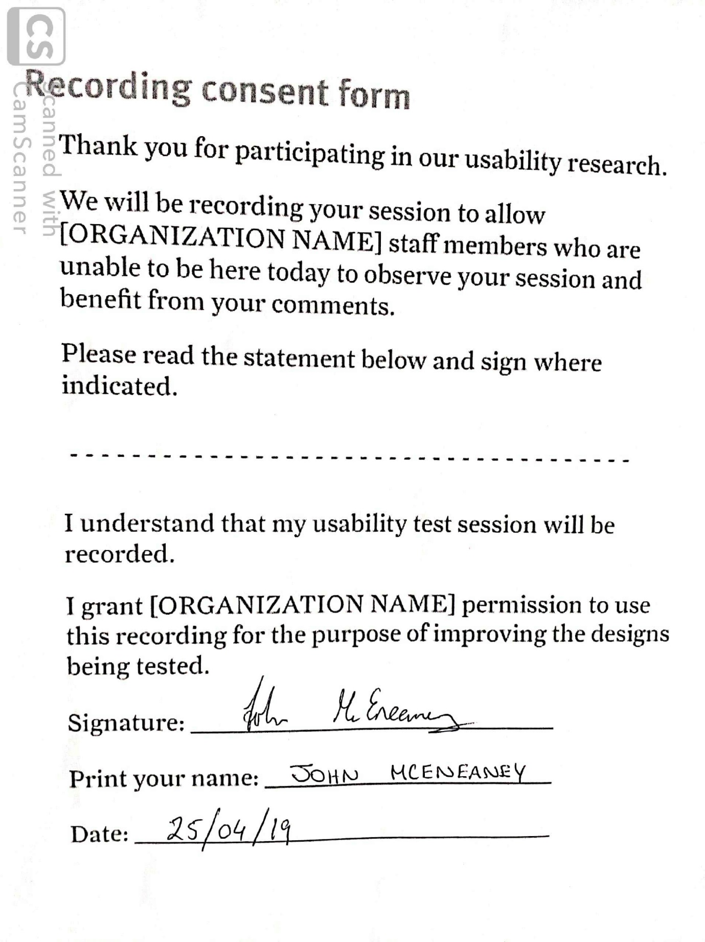

*Figure 2: The Recording contest form for the usability testing on the Bibliography Manager website.*

|  |
| --- |
| Figure 2: Illustration of how technologies are used in Project |

**Front end development**

1. **Approach** **(Specification)**
2. **Problems Faced**
3. **Solution**

**Back end development**

1. **Approach (Specification)**
2. **Problems Faced**
3. **Solution**